Dr. Semmal

Dr. Semmal is the son of Manavai Mustafa (Father of Scientific Tamil) .

Professor Dr Semmal is currently working as Professor of Medical Education in Shaqra University, Riyadh Province in the Kingdom of Saudi Arabia.

Dr Semmal is the Founder and Chief Scientific Advisor of the International Applied Tamil Team

10,000 வருடங்களுக்கு முன்னர் ஆதி மனிதன் மூளை பற்றி என்ன அறிவான் ?

https://youtu.be/MMh6dQyxqsE?si=pTucxnsu-SBZq39I

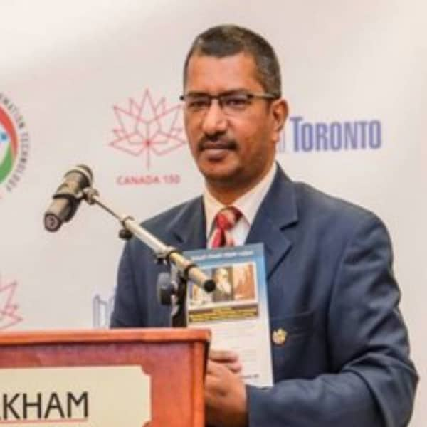
General physician based in Chennai, India,
Over 29 years of medical experience.

Key Details
- Qualification: MBBS (Government Stanley Medical College)
- Specialization: General Physician

- Other Roles:
  - Managing Director of the Manavai Mustafa Scientific Tamil Foundation
  - Associate Professor in Physiology at Sri Ramachandra University
  - Founder and Chief Scientific Advisor of the International Applied Tamil Team

https://www.linkedin.com/in/appliedtamil/

https://youtu.be/zQNvd3U3xds?si=wj4eRbYKUsXoTZlH

Title of the paper:

Imparting Medical and Health Education Using Ancient Tamil Literary Works

Dr.Semmal Syed Meerasa1, Manavai Mustafa2 1. Associate Professor, Department of Physiology, Sri Ramachandra University 2. Founder, Scientific Tamil Foundation

The Academic Community of the 21st century needs to intervene and thereon to responsibly develop innovative educational strategies to alleviate the unhealthy belittling approach in the attitude of generation next towards ancient texts.

The core of the learning module, the 21st Century Approach towards Ancient Literary works (Philocine) is constructed based upon the fascinating principle portrayed by the Evolutionary Biologist Sir. Charles Darwin, that “a constant struggle exists between various life forms as well as various languages and amongst the words in it as well; the better, the shorter, the easier forms will gain an upper hand over others”.

Enumeration of the embedded scientific insights in individual segments of ancient language assemblages by conducting critical analysis by a committed team inclusive from various scientific disciplines is a highly potential area for modern research. Extreme care is to be exercised during analysis to nullify bias in the interpretation process, admixing science and literature in education must be reiterated as a dedicated system of its own.

Benefits of implementing this module with regards to Tamil and the domains of medical and health education are multiple and includes, [1] Creating a generation of Tamil students endowed simultaneously with high quality scientific acumen and oriented to ancient roots of the great Tamil culture. [2] Formation of Integrated Medical Linguistic Research units involving teams of medical professionals and Language scholars across the Universities. [3] Emergence of a new branch in medical education, Philocine – The Philosophical Aspect of Medicine and its constitution as a subspecialty of its own. [4] achieving a radical change in outlook for betterment among the modern youth towards classical Tamil Literature. [5] Forms the foundation of establishing Tamil as the “Most scientifically qualified and oriented of all the classical languages” an attribute well deserved by Tamil. [6] Establishing that science can be learned via ancient Tamil text, enhances the learning potentials and self-esteem levels of Tamil students. [7] Ancient literary works in Tamil crafted at the dawn of human civilizations traverses through the frontiers of Neurobehavioral Evolution. [8] Study material generated in nascent fields of Medical Science like Psychoendoimmunoneurology allows Tamil to gain positive ground amongst other Indian Regional Languages. [9] E - Learning via Educational videos can be created and hosted in free video hosting services like youtube. [10] Creation of International Scientific Publications in English.

Few domains already traversed includes; Elaborating the Insight regarding Freudian Slip of the Tongue phenomenon using the Thirukkural 139 Describing social norm prevalent among ancient Tamils of Tolkappiyam period to propagate sex education related to fertile period of menstrual cycle via literary works Insight related to Genetics of Telomere in relation to Human longevity in Thirukkural numbered three Comparison of thought process of Hippocrates and Thiruvalluvar and Insights regarding Etiology of Obesity in Thirukkural Analysis of Neurophysiological Insights regarding Consolidation on Negative Memory in Thirukkural Scientific Insights in Periyapuraanam Understanding Co - Evolution of Language and Human Brain using Thirukkural numbered one Understanding the Neurophysiological Basis of Education Enhancing Spirituality based on Insight in Thirukkural numbered two

For More Videos Visit - www.tamilarchives.org, an Unit of the அறிவியல் தமிழ் மன்றம் You Tube Channel - The Worlds First non commercial Educational Video channel in Tamil run by a Medical Doctor Dr.Semmal Manavai Mustafa Managing Director, Manavai Mustafa Scientific Tamil Foundation

thetamilarchives@gmail.com

9381045344

